LAB REPORT
ON
Object oriented PROGRAMMING with C++
Phase I

By
Dipak Bahadur Chand
Exam Roll No:
TU Regd. No: 9-2-29-6-2025



Submitted to:
Piyush Pant
Mahendra Ratna Campus

In partial fulfillment of the requirements for the Course
Object Oriented Programming with C++

Tahachal, Kathmandu
September 2026

Table of Contents
1 Write a C++ program to input a number and check whether it is a prime number or not. 1
1.1 Source Code. 1
1.2 Output Window. 2
2 Write a C++ program to find the sum of numbers from 1 to n. 2
2.1 Source Code. 2
2.2 Output Window. 3
3 Write a C++ program to find the factorial of a number using recursion. 3
3.1 Source Code. 3
3.2 Output Window. 4
4 Write a C++ program to calculate the area of a circle, rectangle, and square using method overloading. 4
4.1 Source code. 4
4.2 Output Window. 6
5 Write a C++ program to swap two numbers using pass by value. 6
5.1 Source Code. 6
5.2 Output Window. 7
6 Write a C++ program to swap two numbers using pass by reference. 8
6.1 Source Code. 8
6.2 Output Window. 9
7 Write a C++ program to swap two numbers without using a third variable. 9
7.1 Source Code. 9
7.2 Output Window. 10
8 Write a C++ program to input a number and print its reverse. 10
8.1 Source Code. 10
8.2 Output Window. 11
9 Write a C++ program to demonstrate constructor overloading. 11
9.1 Source Code. 11
9.2 Output window. 13
10 Write a C++ program to demonstrate encapsulation. 13
10.1 Source Code. 13
10.2 Output window. 14
11 Write a C++ program to demonstrate a friend function. 14
11.1 Source Code. 14
11.2 Output Window. 15
12 Write a C++ program to demonstrate a static data member. 16
12.1 Source Code. 16
12.2 Output Window. 17
13 Write a C++ program to demonstrate the execution sequence of constructors in base and derived classes. 18
13.1 Source code. 18
13.2 Output Window. 19
14 Write a C++ program to demonstrate different modes of inheritance. 19
14.1 Source Code. 19
14.2 Output Window. 21
15 Write a C++ program to demonstrate overriding methods. 21
15.1 Source Code. 21
15.2 Output Window. 22
16 Write a C++ program to demonstrate arithmetic operator overloading. 22
16.1 Source Code. 22
16.2 Output Window. 23
17 Write a C++ program to demonstrate relational operator overloading. 24
17.1 Source Code. 24
17.2 Output Window. 25
18 Write a C++ program to demonstrate unary operator overloading. 25
18.1 Source Code. 25
18.2 Output Window. 26
19 Write a C++ program to demonstrate the use of namespaces. 26
19.1 Source Code. 26
19.2 Output Window. 27
20 Write a C++ program to perform addition using a function template. 28
20.1 Source Code. 28
20.2 Output Window. 28
21 Write a C++ program to find the maximum of two values using a function template. 29
21.1 Source Code. 29
21.2 Output Window. 29
22 Write a C++ program to open a file in read mode and display its contents. 30
22.1 Source Code. 30
22.2 Output Window. 31
23 Write a C++ program to open a file in write mode and write data into it. 31
23.1 Source Code. 31
23.2 Output Window. 32
24 Write a C++ program to demonstrate random access file handling and explain how it differs from sequential access. 32
24.1 Source Code. 32
24.2 Output Window. 33
25 Write a C++ program to demonstrate exception handling using try, throw, and catch. 33
25.1 Source Code. 33
25.2 Output Window. 34

Write a C++ program to input a number and check whether it is a prime number or not.

Source Code.
#include <iostream>
using namespace std;

int main() {
int n;
bool isPrime = true;

cout << "Enter a number: ";
cin >> n;

// Numbers less than or equal to 1 are not prime
if (n <= 1) {
isPrime = false;
}
else {
// Check whether the number is divisible by any number
// from 2 up to n/2
for (int i = 2; i <= n / 2; i++) {

// If n is exactly divisible by i,
// then n is not a prime number
if (n % i == 0) {
isPrime = false;
break; // Stop checking further
}
}
}

if (isPrime) {
cout << n << " is a prime number." << endl;
}
else {
cout << n << " is not a prime number." << endl;
}

return 0;
}

Output Window.
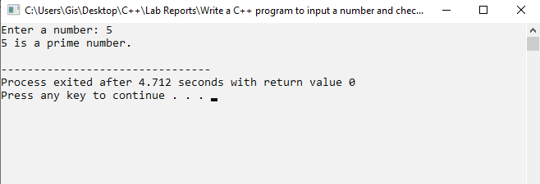

Write a C++ program to find the sum of numbers from 1 to n.

Source Code.
#include <iostream>
using namespace std;

int main()
{
int n, sum = 0;

// Input the value of n
cout << "Enter a number: ";
cin >> n;

// Find the sum of numbers from 1 to n
for (int i = 1; i <= n; i++)
{
sum = sum + i;
}

// Display the result
cout << "Sum of numbers from 1 to " << n << " = " << sum;

return 0;
}

Output Window.
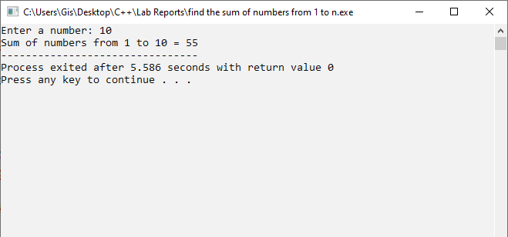

Write a C++ program to find the factorial of a number using recursion.

Source Code.
#include <iostream>
using namespace std;

// Function to find factorial using recursion
int factorial(int n)
{
// Base condition
if (n == 0 || n == 1)
return 1;

// Recursive call
return n * factorial(n - 1);
}

int main()
{
int n;

// Input a number
cout << "Enter a number: ";
cin >> n;

// Display the factorial
cout << "Factorial of " << n << " = " << factorial(n);

return 0;
}

Output Window.
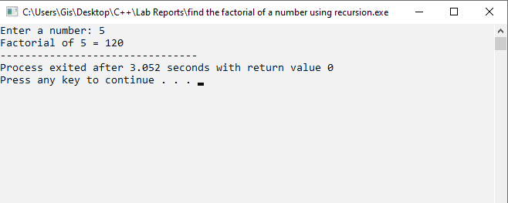

Write a C++ program to calculate the area of a circle, rectangle, and square using method overloading.

Source code.
#include <iostream>
using namespace std;

float area(float r)
{
return 3.14 * r * r;
}

// alculating area of rectangle
int area(int l, int b)
{
return l * b;
}

// calculating area of square
int area(int s)
{
return s * s;
}

int main()
{
float r;
int l, b, s;

// Input radius of circle
cout << "Enter radius of circle: ";
cin >> r;

// Input length and breadth of rectangle
cout << "Enter length and breadth of rectangle: ";
cin >> l >> b;

// Input side of square
cout << "Enter side of square: ";
cin >> s;

// Display areas
cout << "Area of Circle = " << area(r) << endl;
cout << "Area of Rectangle = " << area(l, b) << endl;
cout << "Area of Square = " << area(s) << endl;

return 0;
}

Output Window.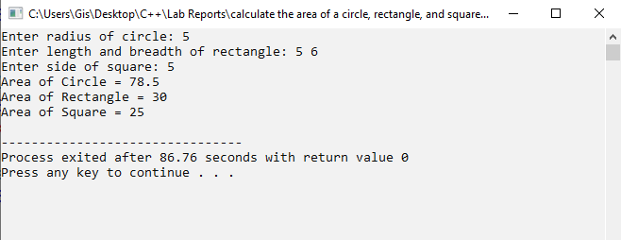

Write a C++ program to swap two numbers using pass by value.

Source Code.
#include <iostream>
using namespace std;

// Function to swap two numbers using pass by value
void swap(int a, int b)
{
int temp;

// Swap the values
temp = a;
a = b;
b = temp;

cout << "Inside function: a = " << a << ", b = " << b << endl;
}

int main()
{
int a, b;

// Input two numbers
cout << "Enter two numbers: ";
cin >> a >> b;

// Display before swapping
cout << "Before swapping: a = " << a << ", b = " << b << endl;

// Function call
swap(a, b);

// Display after swapping
cout << "After swapping: a = " << a << ", b = " << b << endl;

return 0;
}

Output Window.
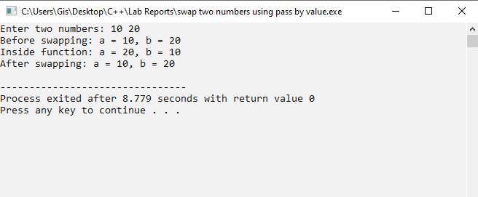

Write a C++ program to swap two numbers using pass by reference.

Source Code.
#include <iostream>
using namespace std;

// Function to swap two numbers using pass by reference
void swap(int &a, int &b)
{
int temp;

// Swap the values
temp = a;
a = b;
b = temp;
}

int main()
{
int a, b;

// Input two numbers
cout << "Enter two numbers: ";
cin >> a >> b;

// Display values before swapping
cout << "Before swapping: a = " << a << ", b = " << b << endl;

// Call the function
swap(a, b);

// Display values after swapping
cout << "After swapping: a = " << a << ", b = " << b << endl;

return 0;
}

Output Window.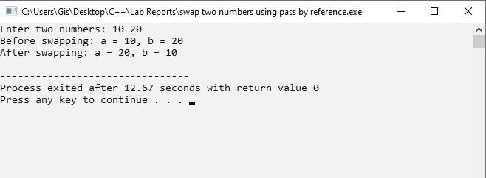

Write a C++ program to swap two numbers without using a third variable.

Source Code.
#include <iostream>
using namespace std;

int main()
{
int a, b;

// Input two numbers
cout << "Enter two numbers: ";
cin >> a >> b;

// Display numbers before swapping
cout << "Before swapping: a = " << a << ", b = " << b << endl;

// Swap without using a third variable
a = a + b;
b = a - b;
a = a - b;

// Display numbers after swapping
cout << "After swapping: a = " << a << ", b = " << b << endl;

return 0;
}

Output Window.
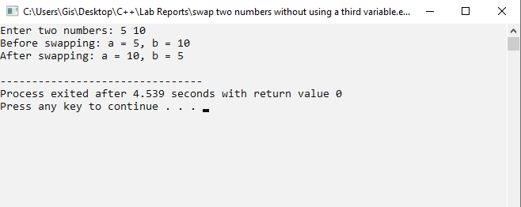

Write a C++ program to input a number and print its reverse.

Source Code.
#include <iostream>
using namespace std;

int main()
{
int n, reverse = 0, remainder;

// Input a number
cout << "Enter a number: ";
cin >> n;

// Find the reverse of the number
while (n != 0)
{
// Get the last digit
remainder = n % 10;

// Add the digit to the reverse
reverse = reverse * 10 + remainder;

// Remove the last digit
n = n / 10;
}

// Display the reversed number
cout << "Reverse = " << reverse;

return 0;
}

Output Window.
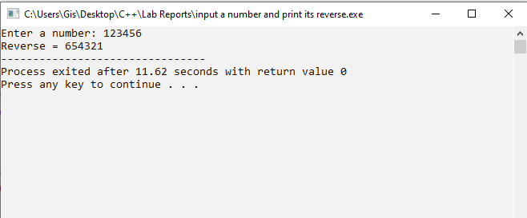

Write a C++ program to demonstrate constructor overloading.

Source Code.
#include <iostream>
using namespace std;

class Student
{
int roll;
string name;

public:

// Default constructor
Student()
{
roll = 0;
name = "Unknown";
}

// Parameterized constructor with one argument
Student(int r)
{
roll = r;
name = "Unknown";
}

// Parameterized constructor with two arguments
Student(int r, string n)
{
roll = r;
name = n;
}

// Function to display student details
void display()
{
cout << "Roll No: " << roll << endl;
cout << "Name: " << name << endl;
}
};

int main()
{
// Calling default constructor
Student s1;

// Calling constructor with one argument
Student s2(101);

// Calling constructor with two arguments
Student s3(102, "Ram");

cout << "Student 1:" << endl;
s1.display();

cout << "\nStudent 2:" << endl;
s2.display();

cout << "\nStudent 3:" << endl;
s3.display();

return 0;
}

Output window.
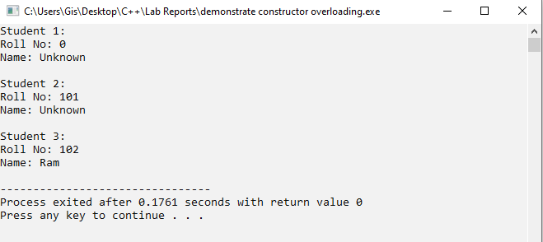

Write a C++ program to demonstrate encapsulation.

Source Code.
#include <iostream>
using namespace std;

class Student
{
private:
// Private data members
int rollNo;
string name;

public:
// Setter function to set values
void setData(int r, string n)
{
rollNo = r;
name = n;
}

// Getter function to display values
void getData()
{
cout << "Roll No: " << rollNo << endl;
cout << "Name: " << name << endl;
}
};

int main()
{
Student s;

// Set student data
s.setData(101, "Ram");

// Display student data
s.getData();

return 0;
}

Output window.
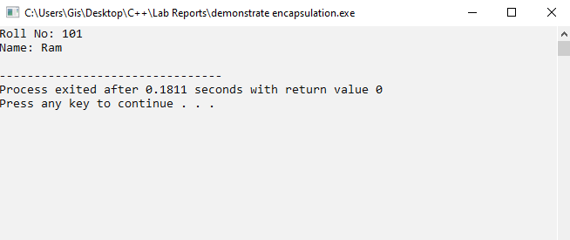

Write a C++ program to demonstrate a friend function.

Source Code.
#include <iostream>
using namespace std;

class Student
{
private:
int marks;

public:
// Function to set marks
void setMarks(int m)
{
marks = m;
}

// Declare friend function
friend void displayMarks(Student s);
};

// Friend function
void displayMarks(Student s)
{
// Friend function can access private data
cout << "Marks = " << s.marks << endl;
}

int main()
{
Student s;

// Set marks
s.setMarks(85);

// Call friend function
displayMarks(s);

return 0;
}

Output Window.
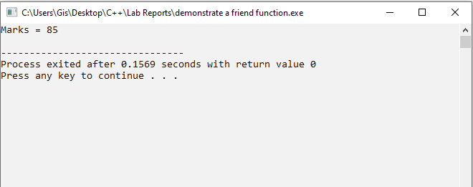

Write a C++ program to demonstrate a static data member.

Source Code.
#include <iostream>
using namespace std;

class Student
{
private:
int rollNo;

public:
// Static data member
static int count;

// Constructor
Student(int r)
{
rollNo = r;
count++;
}

// Function to display roll number
void display()
{
cout << "Roll No: " << rollNo << endl;
}
};

// Initialize static data member
int Student::count = 0;

int main()
{
// Create objects
Student s1(101);
Student s2(102);
Student s3(103);

// Display student details
s1.display();
s2.display();
s3.display();

// Display number of objects created
cout << "Total Students: " << Student::count << endl;

return 0;
}

Output Window.
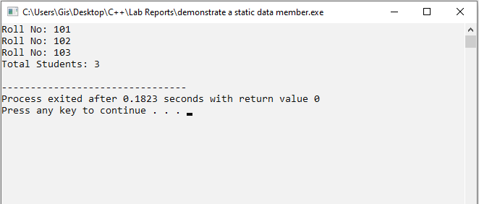

Write a C++ program to demonstrate the execution sequence of constructors in base and derived classes.

Source code.
#include <iostream>
using namespace std;

// Base class
class Base
{
public:
// Base class constructor
Base()
{
cout << "Base class constructor executed." << endl;
}
};

// Derived class
class Derived : public Base
{
public:
// Derived class constructor
Derived()
{
cout << "Derived class constructor executed." << endl;
}
};

int main()
{
// Create an object of derived class
Derived obj;

return 0;
}

Output Window.
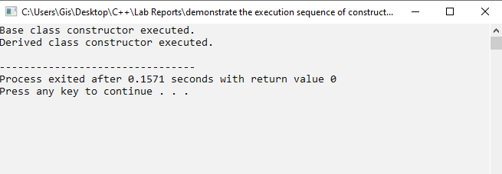

Write a C++ program to demonstrate different modes of inheritance.

Source Code.
#include <iostream>
using namespace std;

class Base
{
public:
int a = 10;

protected:
int b = 20;

private:
int c = 30;
};

// Public inheritance
class PublicDerived : public Base
{
public:
void display()
{
cout << "Public Inheritance: " << a << " " << b << endl;
}
};

// Protected inheritance
class ProtectedDerived : protected Base
{
public:
void display()
{
cout << "Protected Inheritance: " << a << " " << b << endl;
}
};

// Private inheritance
class PrivateDerived : private Base
{
public:
void display()
{
cout << "Private Inheritance: " << a << " " << b << endl;
}
};

int main()
{
PublicDerived obj1;
ProtectedDerived obj2;
PrivateDerived obj3;

// Display values
obj1.display();
obj2.display();
obj3.display();

// Public member can be accessed directly
cout << "Public member: " << obj1.a << endl;

return 0;
}

Output Window.
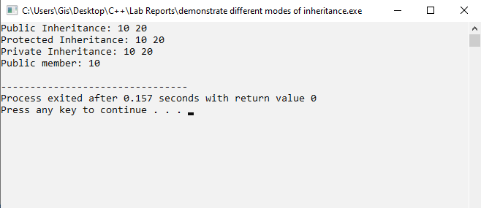

Write a C++ program to demonstrate overriding methods.

Source Code.
#include <iostream>
using namespace std;

// Base class
class Animal
{
public:
// Method in base class
void sound()
{
cout << "Animal makes a sound." << endl;
}
};

// Derived class
class Dog : public Animal
{
public:
// Overriding the sound() method
void sound()
{
cout << "Dog barks." << endl;
}
};

int main()
{
Animal a;
Dog d;

// Call base class method
a.sound();

// Call overridden method
d.sound();

return 0;
}

Output Window.
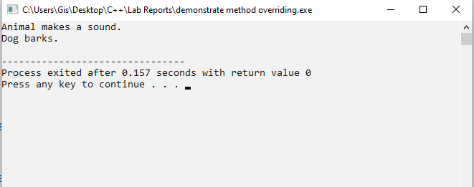

Write a C++ program to demonstrate arithmetic operator overloading.

Source Code.
#include <iostream>
using namespace std;

class Number
{
private:
int value;

public:
// Constructor
Number(int v)
{
value = v;
}

// Overload + operator
Number operator+(Number n)
{
return Number(value + n.value);
}

// Function to display value
void display()
{
cout << "Result = " << value << endl;
}
};

int main()
{
// Create two objects
Number n1(10);
Number n2(20);

// Add two objects using overloaded + operator
Number n3 = n1 + n2;

// Display result
n3.display();

return 0;
}

Output Window.
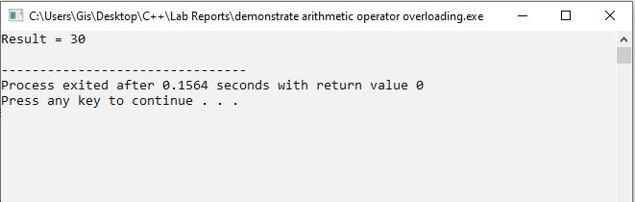

Write a C++ program to demonstrate relational operator overloading.

Source Code.
#include <iostream>
using namespace std;

class Number
{
private:
int value;

public:
// Constructor
Number(int v)
{
value = v;
}

// Overload + operator
Number operator+(Number n)
{
return Number(value + n.value);
}

// Function to display value
void display()
{
cout << "Result = " << value << endl;
}
};

int main()
{
// Create two objects
Number n1(10);
Number n2(20);

// Add two objects using overloaded + operator
Number n3 = n1 + n2;

// Display result
n3.display();

return 0;}

Output Window.
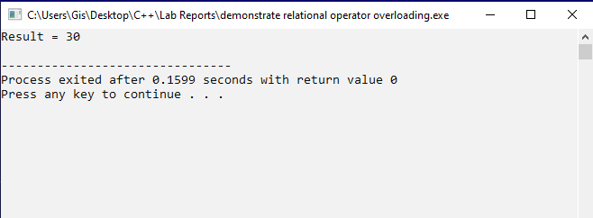

Write a C++ program to demonstrate unary operator overloading.

Source Code.
#include <iostream>
using namespace std;

class Number
{
private:
int value;

public:
// Constructor
Number(int v)
{
value = v;
}

// Overload unary ++ operator
void operator++()
{
++value;
}

// Function to display value
void display()
{
cout << "Value = " << value << endl;
}
};

int main()
{
// Create an object
Number n(10);

// Display original value
cout << "Before increment:" << endl;
n.display();

// Call overloaded ++ operator
++n;

// Display value after increment
cout << "After increment:" << endl;
n.display();

return 0;
}

Output Window.
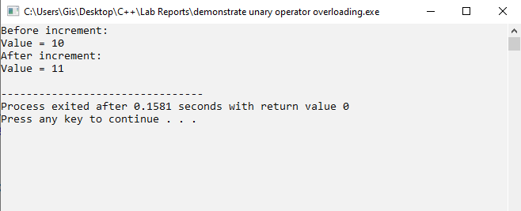

Write a C++ program to demonstrate the use of namespaces.

Source Code.
#include <iostream>
using namespace std;

// First namespace
namespace First
{
int value = 10;

void display()
{
cout << "Value from First namespace = " << value << endl;
}
}

// Second namespace
namespace Second
{
int value = 20;

void display()
{
cout << "Value from Second namespace = " << value << endl;
}
}

int main()
{
// Access members using namespace name
First::display();
Second::display();

return 0;
}

Output Window.
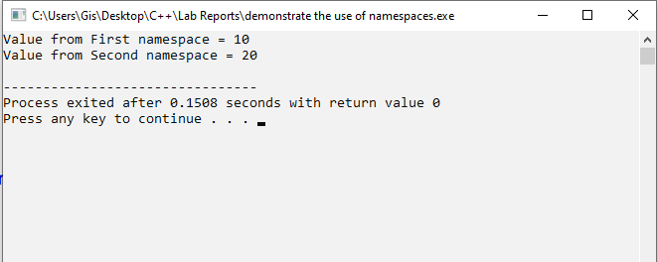

Write a C++ program to perform addition using a function template.

Source Code.
#include <iostream>
using namespace std;

// Function template for addition
template <class T>
T add(T a, T b)
{
return a + b;
}

int main()
{
int a, b;

// Input two numbers
cout << "Enter two numbers: ";
cin >> a >> b;

// Call function template
cout << "Sum = " << add(a, b) << endl;

return 0;
}

Output Window.
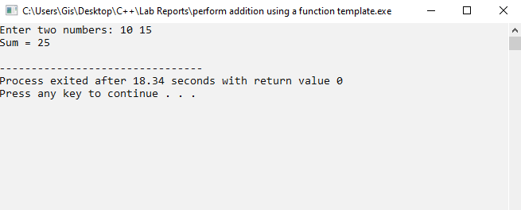

Write a C++ program to find the maximum of two values using a function template.

Source Code.
#include <iostream>
using namespace std;

// Function template to find maximum
template <class T>
T maximum(T a, T b)
{
// Compare two values
if (a > b)
return a;
else
return b;
}

int main()
{
int a, b;

// Input two values
cout << "Enter two values: ";
cin >> a >> b;

// Display maximum value
cout << "Maximum = " << maximum(a, b) << endl;

return 0;
}

Output Window.
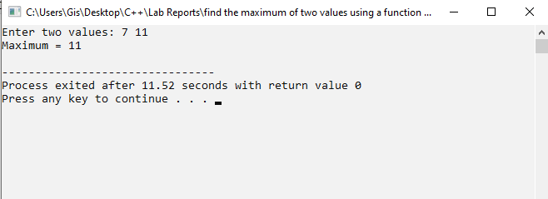

Write a C++ program to open a file in read mode and display its contents.

Source Code.
#include <iostream>
#include <fstream>
using namespace std;

int main()
{
string line;

// Open the file in read mode
ifstream file("data.txt");

// Check if the file opened successfully
if (!file)
{
cout << "Unable to open file." << endl;
return 1;
}

// Read the file line by line
while (getline(file, line))
{
// Display each line
cout << line << endl;
}

// Close the file
file.close();

return 0;
}

Output Window.
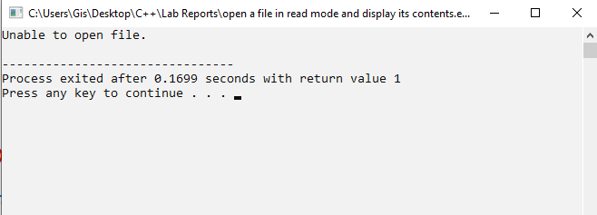

Write a C++ program to open a file in write mode and write data into it.

Source Code.
#include <iostream>
#include <fstream>
using namespace std;

int main()
{
// Open file in write mode
ofstream file("data.txt");

// Check if the file opened successfully
if (!file)
{
cout << "Unable to open file." << endl;
return 1;
}

// Write data into the file
file << "Hello World!" << endl;
file << "This is a C++ file handling program." << endl;
file << "Welcome to C++ programming." << endl;

// Close the file
file.close();

cout << "Data written successfully." << endl;

return 0;
}

Output Window.
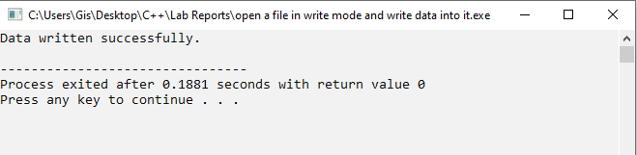
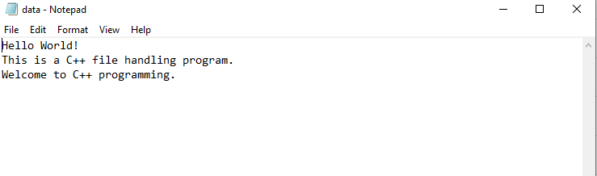

Write a C++ program to demonstrate random access file handling and explain how it differs from sequential access.

Source Code.
#include <iostream>
#include <fstream>
using namespace std;

int main()
{
// Open file in read and write mode
fstream file("data.txt", ios::in | ios::out);

// Check if file opened successfully
if (!file)
{
cout << "Unable to open file." << endl;
return 1;
}

// Move the file pointer to the beginning
file.seekg(0);

// Read data from a specific position
file.seekg(6);

char ch;
file.get(ch);

// Display the character at position 6
cout << "Character at position 6 = " << ch << endl;

// Close the file
file.close();

return 0;
}

Output Window.
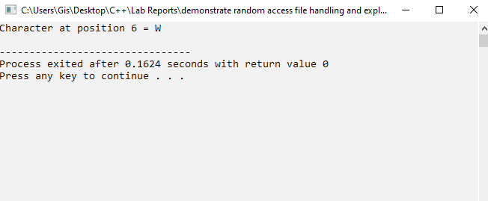

Write a C++ program to demonstrate exception handling using try, throw, and catch.

Source Code.
#include <iostream>
using namespace std;

int main()
{
int a, b;

// Input two numbers
cout << "Enter two numbers: ";
cin >> a >> b;

try
{
// Check for division by zero
if (b == 0)
{
// Throw an exception
throw b;
}

cout << "Result = " << a / b << endl;
}

catch (int x)
{
// Handle the exception
cout << "Error: Cannot divide by zero." << endl;
}

return 0;
}

Output Window.
